**Code / User Manual**

**Code Manual**

*Module + Timetable Database Layout*

Each module has its own occurrence and each occurrence has Monday to Friday as Children. Each day has 11 Time Children, which contains where the lesson is in that time block.

*Timetable Database Formatting*

Class locations are formatted by building letter in higher case, floor letter in lowercase and door number for example: Invicta, First Floor, 15 = If15.

For empty slots in the timetable, we’ve populated it with ‘None’.

*Timetable Database Evidence*

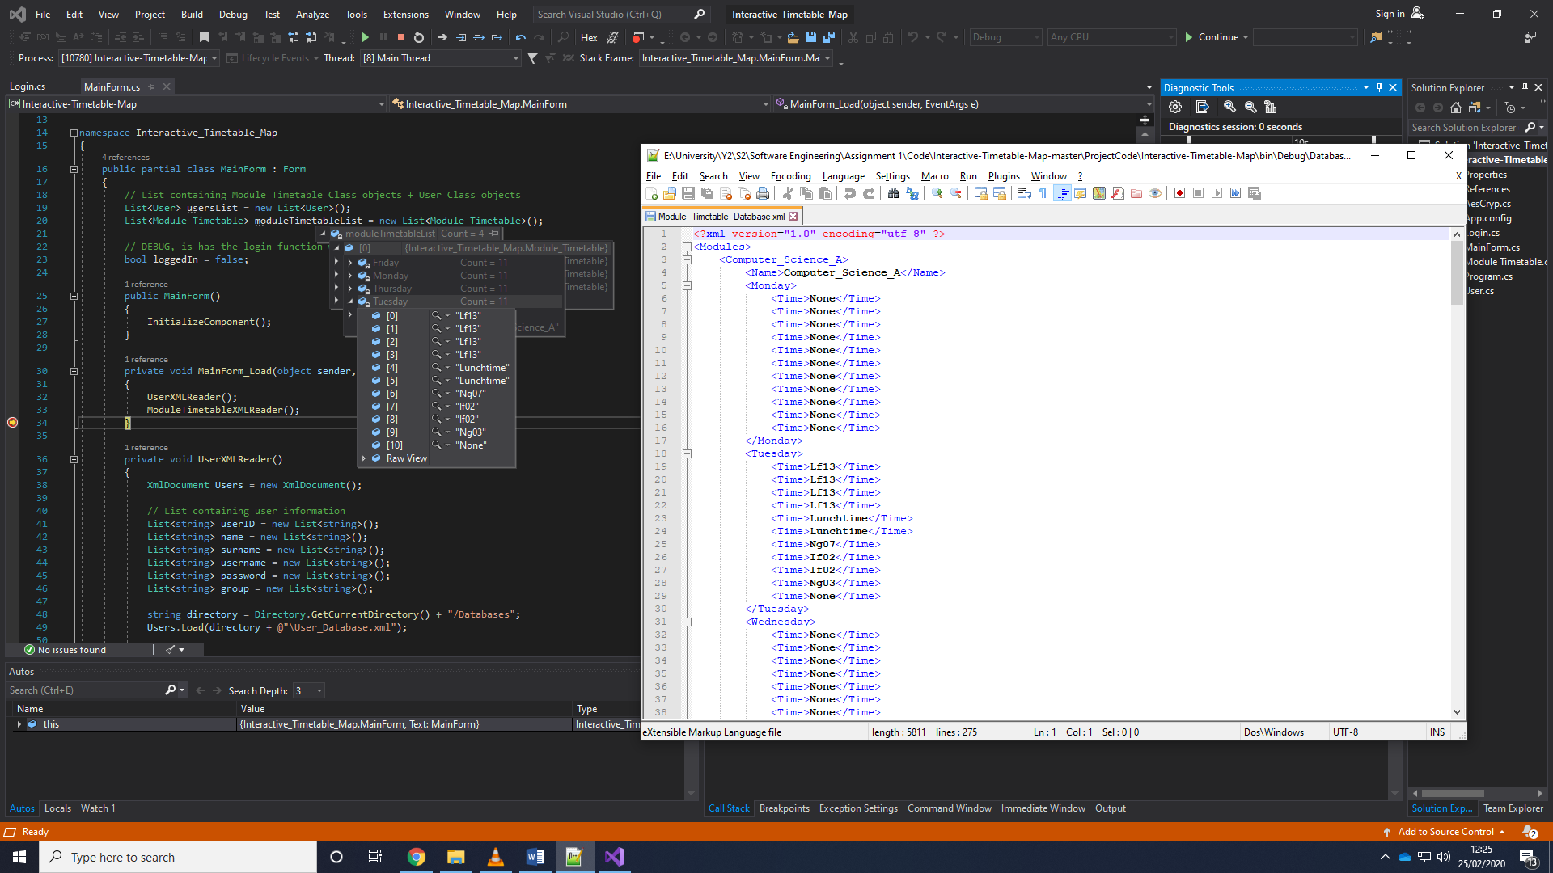

*User Database:*

For each user, we have populated it using id, name, surname, username, password and group letter.

*User Database Layout*

Each User has its own occurrence, which contains the Children with the User information.

*User Database Evidence*

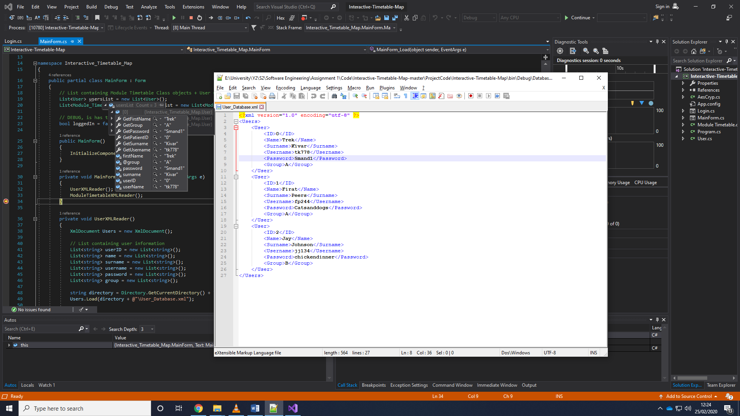

*Login Function*

The user types their username and password into the correct boxes. If both are right, then the user will be logged in. If one or both are wrong, the user will be returned with an error.

The user may Register new users, but at the moment this does not add them to the User Database.XML

*Login Evidence*

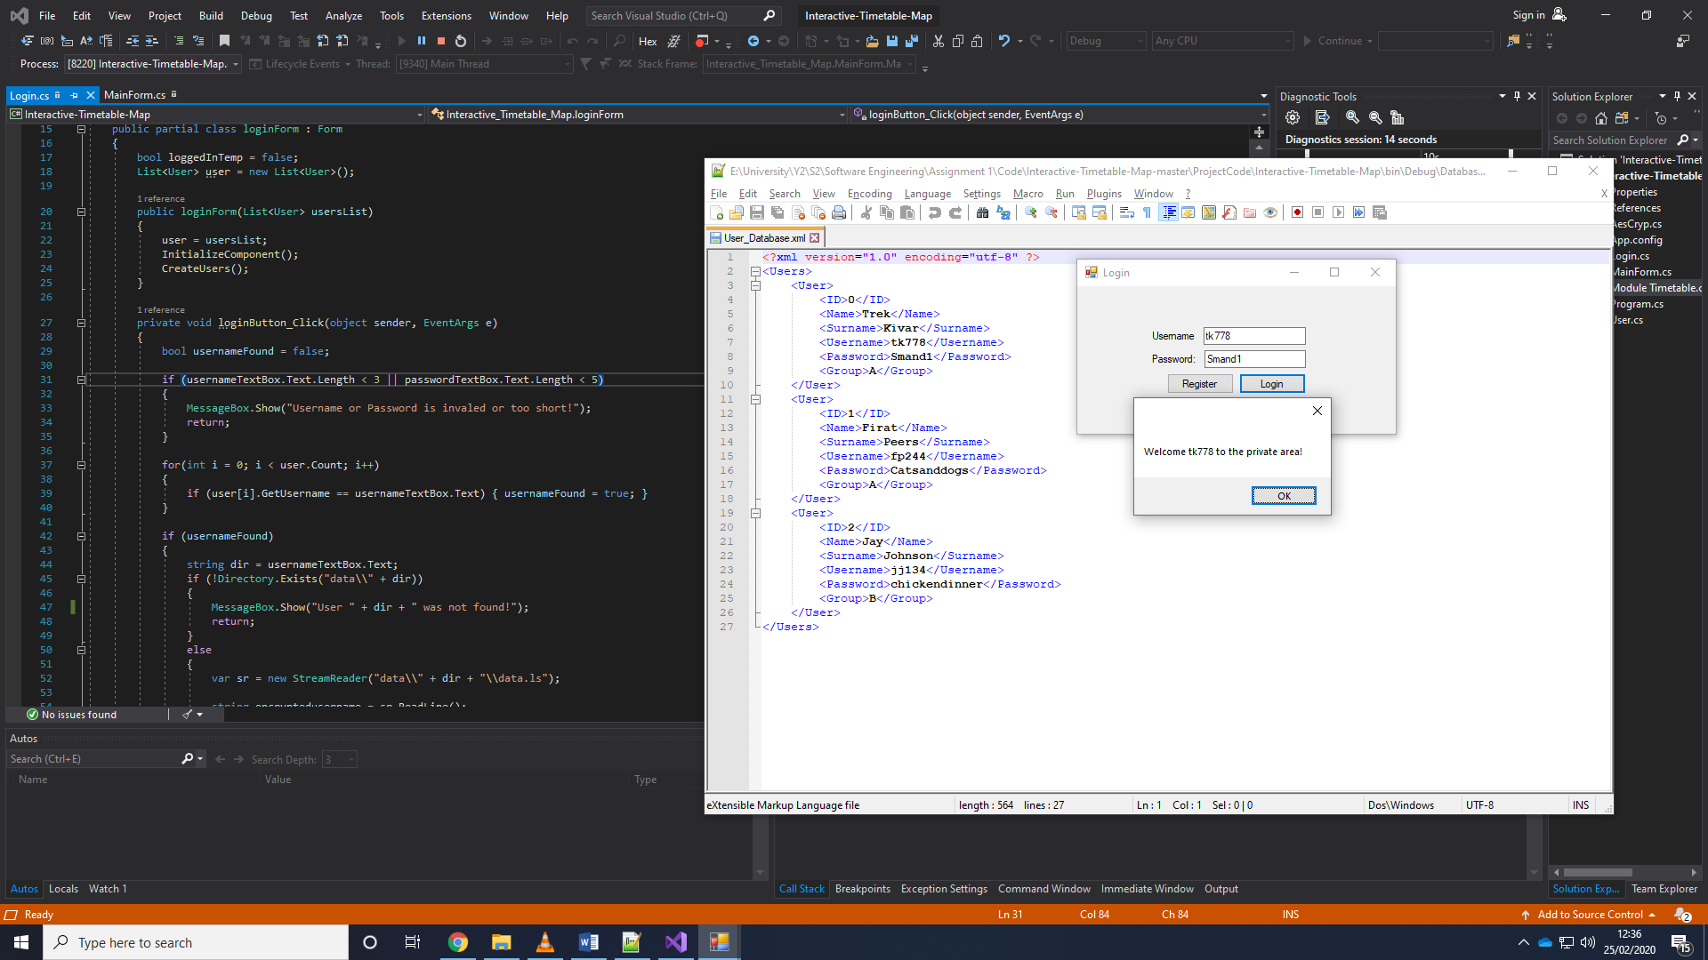

**User Manual**

*UI:*

Left side of the program is used to display the timetable.

Right side of the program is used for users to login. It’s also used for admins to edit, add and remove users and their corresponding timetables onto the database.